Add food for a particular day

Document Information

|  |  |
| --- | --- |
| **Document Title** | Title of use case – Verb Noun phrasing is almost always the most appropriate! |
| **Document Owner** |  |
| **Version** |  |
| **Status** |  |
| **Date** |  |

1. Brief Description

This use case allows the school administrator to add food items for a specific day.

1. Actors

* School Administrator

1. Trigger

The school administrator wants to add food items for a specific day.

1. Pre-Conditions

* The school administrator must be logged in to the system.
* The food items must already exist in the system.

1. Post-Conditions

* The food item is added to the selected day.

1. Basic Flow
2. The school administrator selects the "Lunch Schedule" menu.
3. The system displays a calendar for the administrator to select a specific day.
4. The school administrator selects a day.
5. The system displays the food items that have already been added for that day.
6. The school administrator selects the "Add Food" button.
7. The system displays a list of food items already exist in the system.
8. The school administrator selects the food item they want to add.
9. The school administrator enters the quantity of the food item to be added.
10. The school administrator selects the “Add Selected Product(s)” button.
11. The system adds the food item and quantity to the selected day.
12. Alternate Flows

• 5a: The school administrator search for the food item name at the Search bar. Then continue step 7.

1. Exception Flows

* 4a: If the selected day is the day in the past, the “Add Food” button does not exist.
* 6a: If there are not any food item existed, the system displays an empty list. The school administrator selects the “Cancel” button to go back to step 4.
* 10a: If the system encounters an error while saving the changes, the system displays an error message and prompts the school administrator to try again. The school administrator is returned to step 6.
* 10b: If the selected food item is already added, the system updates the quantity by adding the new quantity to the current quantity.

1. Business Rules

* The food item must already exist in the system to be added.
* The quantity of the food item must be positive.

1. Non-Functional Requirements

* The selected day can be added unlimited food items and unlimited food item’s quantity.
* The system must save the changes immediately after the food items are added (1s).

1. Supplemental Requirements
2. Visual Model

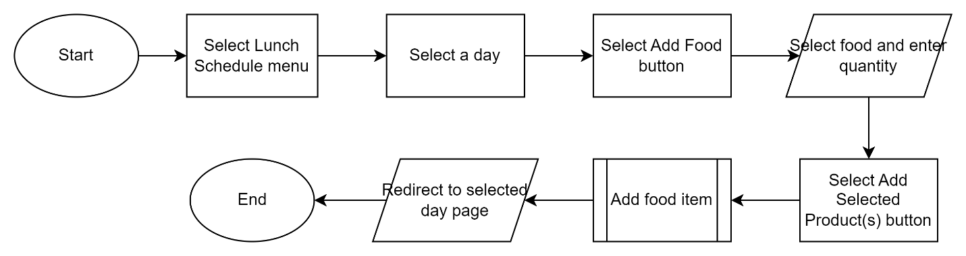

Revision History

|  |  |  |  |  |
| --- | --- | --- | --- | --- |
| V. | Date | Author | Description | Status |
|  |  |  |  |  |
|  |  |  |  |  |